***Báo Cáo Đồ Án Cá Nhân***

(Game Bầu Cua )

Nhóm 4

Đoàn Vũ Quốc Khiêm

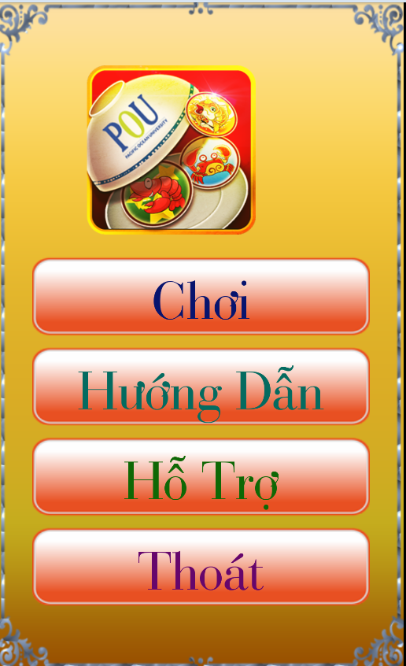Môn: LTDD2

Báo Cáo:Màn hình Menu

*<?***xml version="1.0" encoding="utf-8"***?>*<**LinearLayout xmlns:android="http://schemas.android.com/apk/res/android"  
 xmlns:tools="http://schemas.android.com/tools"  
 android:id="@+id/activity_menu"  
 android:layout_width="match_parent"  
 android:layout_height="match_parent"  
 android:background="@drawable/backgroundb"  
 android:gravity="center"  
 android:orientation="vertical"  
 android:paddingBottom="@dimen/activity_vertical_margin"  
 android:paddingLeft="@dimen/activity_horizontal_margin"  
 android:paddingRight="@dimen/activity_horizontal_margin"  
 android:paddingTop="@dimen/activity_vertical_margin"  
 tools:context="com.ae4.nhom_4.Menu"**>  
<**ImageView  
 android:id="@+id/icon"  
 android:layout_width="150dp"  
 android:layout_height="150dp"  
 android:src="@drawable/icon"**/>  
 <**FrameLayout  
 android:id="@+id/framLayoutplay"  
 android:layout_width="wrap_content"  
 android:layout_height="wrap_content"  
 android:background="@drawable/playbutton"  
 android:layout_marginTop="20dp"**>  
  
  
 <**TextView  
 android:id="@+id/textplay"  
 android:layout_width="match_parent"  
 android:layout_height="match_parent"  
 android:layout_gravity="center"  
 android:text="Chơi"  
 android:textColor="#08146e"  
 android:textSize="50dp"  
 android:textStyle="bold"  
 tools:text="Chơi"** />  
 </**FrameLayout**>  
  
 <**FrameLayout  
 android:id="@+id/framLayoutsuport"  
 android:layout_width="wrap_content"  
 android:layout_height="wrap_content"  
 android:background="@drawable/playbutton"  
 android:layout_marginTop="10dp"**>  
  
  
 <**TextView  
 android:id="@+id/textsuport"  
 android:layout_width="wrap_content"  
 android:layout_height="wrap_content"  
 android:layout_gravity="center"  
 android:text="Hướng Dẫn"  
 android:textColor="#046b60"  
 android:textSize="50dp"  
 android:textStyle="bold"  
 tools:text="Hướng Dẫn"** />  
 </**FrameLayout**>  
  
 <**FrameLayout  
 android:id="@+id/framLayoutabout"  
 android:layout_width="wrap_content"  
 android:layout_height="wrap_content"  
 android:background="@drawable/playbutton"  
 android:layout_marginTop="10dp"**>  
  
 <**TextView  
 android:id="@+id/textabout"  
 android:layout_width="wrap_content"  
 android:layout_height="wrap_content"  
 android:layout_gravity="center"  
 android:text="Hỗ Trợ"  
 android:textColor="#0f6805"  
 android:textSize="50dp"  
 android:textStyle="bold"  
 tools:text="Hỗ Trợ"** />  
 </**FrameLayout**>  
  
 <**FrameLayout  
 android:id="@+id/framLayoutexit"  
 android:layout_width="wrap_content"  
 android:layout_height="wrap_content"  
 android:background="@drawable/playbutton"  
 android:layout_marginTop="10dp"**>  
  
 <**TextView  
 android:id="@+id/textexit"  
 android:layout_width="wrap_content"  
 android:layout_height="wrap_content"  
 android:layout_gravity="center"  
 android:text="Thoát"  
 android:textColor="#66066c"  
 android:textSize="50dp"  
 android:textStyle="bold"  
 tools:text="Thoát"** />  
 </**FrameLayout**>  
  
  
</**LinearLayout**>

Mô tả màn hình: gồm có 4 text view và 4 FrameLayout lẫn 4 button .Với mỗi button có 1 chức năng riêng khi ta click vào nó sẽ hiện ra 1 màn hình khác .Logo có animation với chuyển động qua lại đồng thời có hiệu ứng làm mờ.

|  |  |  |  |
| --- | --- | --- | --- |
| STT | Mô tả | Thực hiện | Chức năng |
| 1 | Button chơi | click | vào màn hình chơi game main activity |
| 2 | Button hướng dẫn | click | vào màn hình support activity để xem hướng dẫn |
| 3 | Button hỗ trợ | click | vào màn hình about activity để nhận trợ cấp |
| 4 | Button thoát | click | thoát khỏi game |

Animation của logo icon có chuyển động qua lại với làm mờ:

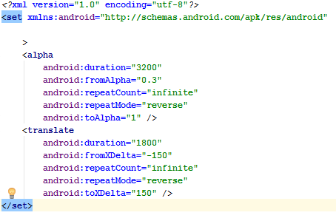

Code:

**package** com.ae4.nhom_4;  
  
**import** android.content.Intent;  
**import** android.graphics.Typeface;  
**import** android.media.MediaPlayer;  
**import** android.support.v7.app.AppCompatActivity;  
**import** android.os.Bundle;  
**import** android.view.View;  
**import** android.view.WindowManager;  
**import** android.view.animation.Animation;  
**import** android.view.animation.AnimationUtils;  
**import** android.widget.FrameLayout;  
**import** android.widget.ImageView;  
**import** android.widget.TextView;  
  
**public class** Menu **extends** AppCompatActivity **implements** View.OnClickListener {  
 MediaPlayer **tick_music**;  
 Typeface **typeface**;  
 FrameLayout **frameLayoutplay**,  
 **frameLayoutabout**,  
 **frameLayoutsuport**,  
 **frameLayoutexit**;  
 TextView **textplay**,  
 **textabout**,  
 **textsuport**,  
 **textexit**;  
 Animation **animation**;  
 ImageView **icon**;  
  
 @Override  
 **protected void** onCreate(Bundle savedInstanceState) {  
 **super**.onCreate(savedInstanceState);  
 setContentView(R.layout.***activity_menu***);  
 **this**.getWindow().setFlags(WindowManager.LayoutParams.***FLAG_FULLSCREEN***,  
 WindowManager.LayoutParams.***FLAG_FULLSCREEN***);  
 AnhXa();  
 }// lấy âm thanh và cho ra layout của màn hình MENU  
  
 **private void** AnhXa() {  
 **animation**= AnimationUtils.*loadAnimation*(**this**,R.anim.***anim_icon***);  
 **typeface**=Typeface.*createFromAsset*(getAssets(),**"test.ttf"**);  
  
 **icon**= (ImageView) findViewById(R.id.***icon***);  
 **icon**.startAnimation(**animation**);//Load animation cho logo

  
  
 **frameLayoutplay**= (FrameLayout) findViewById(R.id.***framLayoutplay***);  
 **frameLayoutabout**= (FrameLayout) findViewById(R.id.***framLayoutabout***);  
 **frameLayoutsuport**= (FrameLayout) findViewById(R.id.***framLayoutsuport***);  
 **frameLayoutexit**= (FrameLayout) findViewById(R.id.***framLayoutexit***);  
  
 **textplay**= (TextView) findViewById(R.id.***textplay***);  
 **textsuport**= (TextView) findViewById(R.id.***textsuport***);  
 **textabout**= (TextView) findViewById(R.id.***textabout***);  
 **textexit**= (TextView) findViewById(R.id.***textexit***);  
  
 **textplay**.setTypeface(**typeface**);  
 **textabout**.setTypeface(**typeface**);  
 **textsuport**.setTypeface(**typeface**);  
 **textexit**.setTypeface(**typeface**);  
  
 **tick_music**=MediaPlayer.create(**this**,R.raw.***button9***);  
  
 **frameLayoutplay**.setOnClickListener(**this**);  
 **frameLayoutabout**.setOnClickListener(**this**);  
 **frameLayoutexit**.setOnClickListener(**this**);  
 **frameLayoutsuport**.setOnClickListener(**this**);  
 }  
  
 @Override  
 **public void** onClick(View view) {  
 **tick_music**.start();  
  
 **if**(view==**frameLayoutabout**) {  
 Intent intent2=**new** Intent(Menu.**this**,AboutActivity.**class**);  
 startActivity(intent2);  
 }**else if**(view==**frameLayoutexit**) {  
 Menu.**this**.finish();  
 }**else if**(view==**frameLayoutsuport**) {  
 Intent intent2=**new** Intent(Menu.**this**,SupportActivity.**class**);  
 startActivity(intent2);  
 }**else if**(view==**frameLayoutplay**) {  
 Intent intent2=**new** Intent(Menu.**this**,MainActivity.**class**);  
 startActivity(intent2);  
 }  
 Menu.**this**.finish();  
 }  
}

//chức năng khi click vào các button sẽ hiển thị sang trang khác